For download


Trusted Medical Supplies Manufacturer

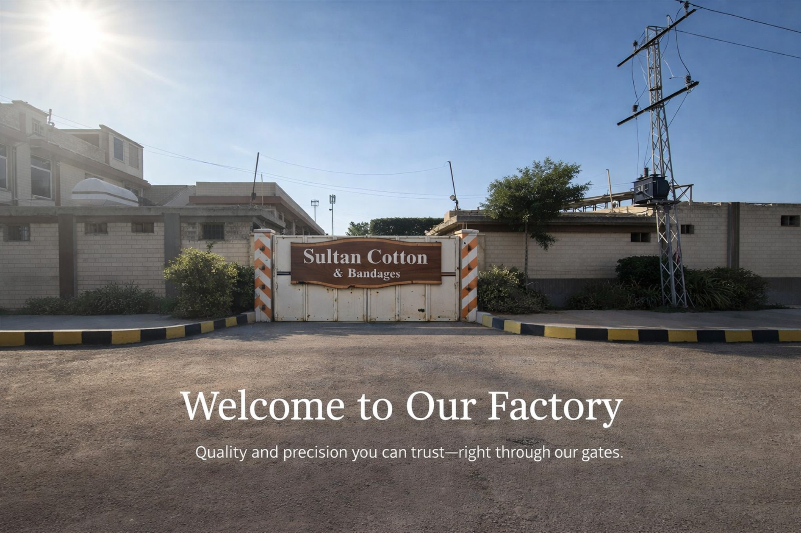

Binding Wounds, Building Trust

About Us
Sultan Cotton & Bandages is a Pakistan-based manufacturer of high-quality medical disposables. For over 20 years, we have been supplying hospitals, clinics, pharmacies, and distributors across Pakistan. Our commitment to quality, compliance, and consistency has made us a trusted name in healthcare.

Our Product Range
Cotton Bandages | Cotton Wool
Crepe Bandages | Gauze Lint
Gauze Pads (USP Type IV & BPC) | Gauze Roll

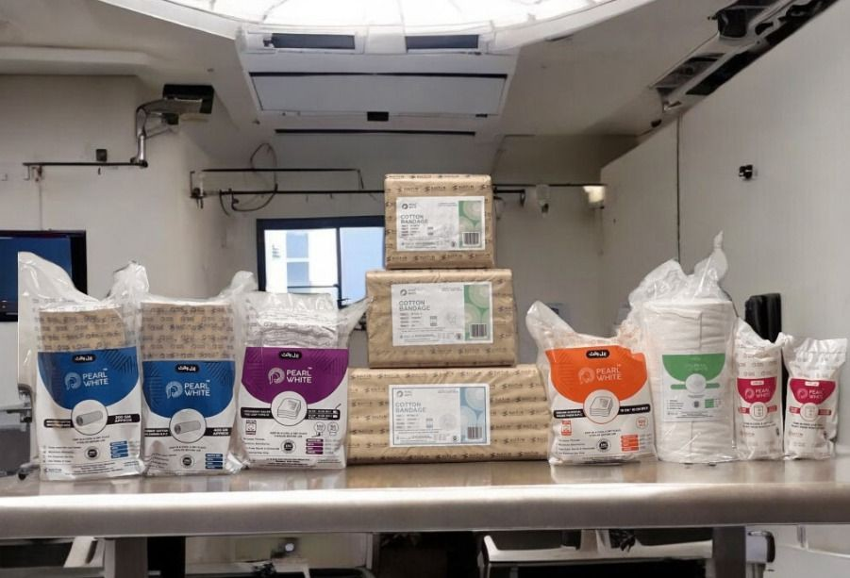

Compliance & Certifications
Our manufacturing operations strictly follow national and international quality standards:
- DRAP Manufacturing License
- DRAP Product Registration
- GMP Certified Facility
- ISO 9001:2015 – Quality Management System
- ISO 14001:2015 – Environmental Management System

Manufacturing Strength
Our factory is equipped with modern machinery, a skilled workforce, and rigorous quality control systems. From raw material selection to final packaging, every stage is carefully monitored to ensure safety and reliability.

Market Presence
Our cotton bandages and cotton wool are among the best-selling medical disposables in Pakistan, widely trusted by healthcare professionals for consistent performance and dependable quality.

Our Valued Clients
- Agha Khan Health Services
- Liaquat National Hospital
- Tabba Heart Institute
- Patel Hospital
- Saifee Hospital
- Shaheed Mohtarma Benazir Bhutto Medical University (SMBBMU)
- Friends of Burns Centre
- Zubaida Medical Centre (ZMC)
- Marie Stopes Society
- Bantva Memon Khidmat Committee
- Bin Hashim Pharmacy & Supermarket
- Government Tenders – Multiple Departments

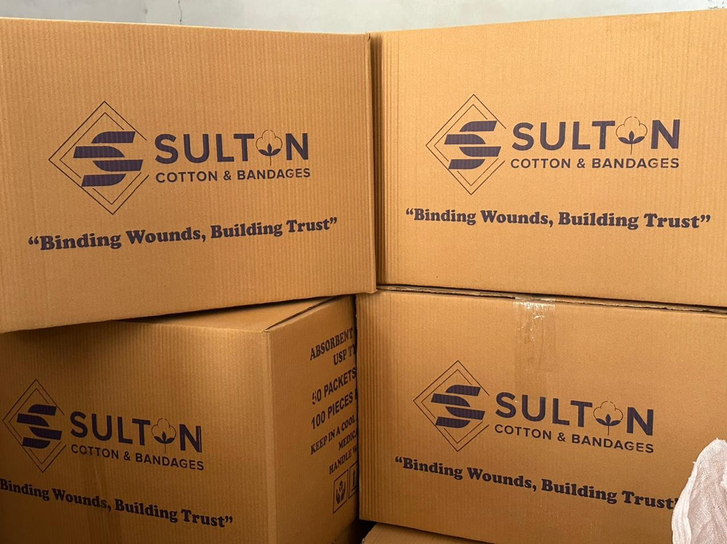

Sultan Cotton & Bandages continues to serve the healthcare sector with integrity, quality, and trust.

